VCNA
Cement Division
Job Description Maintenance Supervisor

Job Title: Mechanical Maintenance Supervisor | Date Prepared: November 2018
Incumbent Name: | Division / Department: Cement Operations
Reports to (Title & Name): Mechanical Maintenance Manager
New position: Y or N
Existing position (re-drafted to reflect additional duties): Y or N Re-drafted for Salary Non-Exempt

Job Purpose (A brief overview of the purpose of the job and why it exists)
Promotes the use of protective and preventative maintenance systems and techniques to improve principle operating equipment and system liability by performing the following duties personally.

Key Job Functions and Accountabilities (List the major functions of the job and identify the time spent on each activity on an annual basis) (5-7 main activities is sufficient) | % of Time Spent on Function on an Annualized Basis
1.  Directs and supervises workers engaged in repairing, dismantling, assembling, and installing industrial equipment on an as required basis, and is one of the week-end on-call supervisory staff. Supervises drive-coupling alignments, balancing and oil analysis to make recommendations that support the data found. | 50%
2.  Evaluates cost reduction opportunities; introduces new preventative maintenance technology programs and ensures these programs meet manufacturer, company, and industry standards. | 15%
3.  Records and analyzes data to determine mechanical problems.  Troubleshoots any equipment and/or machinery malfunctions to determine root cause(s) and develops corrective action plans to rectify the problems. Updates existing plant maintenance and preventative maintenance systems. Creates weekly and monthly plant equipment condition status reports | 20%
4.  Conducts technical reviews of vendors and contractors to ensure that they are capable of providing the equipment, machinery, and/or services that we require. Participate in preparation of annual budget. | 5%
5.  Maintains a strong relationship with the Union: deals with daily union issues/concerns, responsible for Step 1 grievance | 10%
Organization Structure (Overview of structure where job is located –Attach an updated organizational chart)
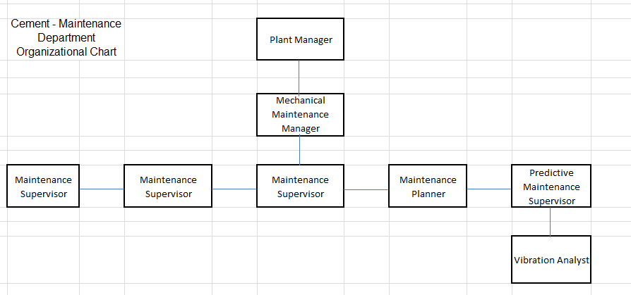

KNOW HOW -Know How includes every kind of relevant knowledge, skill and experience, however acquired, needed for acceptable performance in a job or role.
Skills –
- Ability to read and interpret documents such as safety rules, operating and maintenance instructions, and procedure manuals.
- Ability to write routine reports and correspondence.
- Ability to speak effectively before groups of customers or employees of organization.
- Ability to calculate figures and amounts such as discounts, interest, commissions, proportions, percentages, area, circumference, and volume. Ability to apply concepts of basic algebra and geometry.
- Computer skill: knowledge of Internet, MS Office, CAD, Power Point; SAP and advanced user of Excel.

Education – Two-year college or technical school; plus one to two years related experience and/or training; or equivalent combination of education and experience.

Experience - Ten years’ related and progressive managerial experience.

Knowledge (technical/practical/managerial)-
- Ability to apply common sense understanding to carry out instructions furnished in written, oral, or diagram form. Ability to deal with problems involving several concrete variables in standardized situations.
- Mechanical Aptitude
PROBLEM SOLVING – Problem Solving is the amount and nature of the thinking required in the job in the form of analyzing, reasoning, evaluating, creating, using judgment, forming hypotheses, drawing inferences and arriving at conclusions.

Please identify the degree to which thinking is limited by roles, procedures, precedents, policies, strategy, etc.:
Reports directly to Mechanical Maintenance Manager; writes procedures not policies; compliant to company policies and procedures.

Please describe the complexity of the problems encountered and the extent to which original thinking must be used to arrive at solutions:

Variable situations requiring analytical, interpretative, evaluative, and/or constructive thinking

ACCOUNTABILITY – Accountability assesses the extent to which a job/role is answerable for actions and their consequences. It measures the effect of the job/role on end-results.
- Please describe the level of autonomy the position possess in terms of deciding on the measures and actions to be taken to achieve the required results:
e.g. the position has very little freedom – the role is closely controlled and operates within direct and detailed work instructions with very close supervision.
The role is subject to broad practices and procedures covered by functional precedents and policies,
- If this position manages an operating budget, please choose indicate the amount. NA
- $80,000-$800,000
- $800,000-$8 million
- $8 million-$80 million
- $80 million-$800 million
- $800 million-$8 billion
- Not applicable

- Any other quantitative data such as sales revenue, capital expenditures, etc., should be indicated: NA
Working Conditions (Please indicate the intensity, frequency and duration of each condition described below)
Physical Effort: The combination of intensity, duration, and frequency of physical activity is such that it results in:
□ Minimal-alternating positions of light physical activities, e.g., sitting, standing, walking, bending, lifting etc.
□ Moderate-intermediate positions of moderate physical activity, e.g., sitting in one place, standing, walking, sustained keyboarding, working in awkward or constrained physical positions or confined/restricted space for up to 50% of the work day
□ Considerable-frequent lengthy periods of heavy physical effort, e.g., if the above is performed for 51% to 80% if the work day
□ Extreme-Almost continuous and lengthy durations of heavy physical activity, e.g., lifting heavy weight objects and or performing the above for more than 80% of the work day

Physical Environment: The combination of intensity, duration, and frequency of exposure to factors in the environment is such that it results in:
□ Occasional exposure to mild unpleasant or disagreeable conditions e.g. dust, dirt, odours, noise etc. While performing the duties of this job, the employee is occasionally exposed to moving mechanical parts., extreme heat adjacent to kiln, occasionally exposed to dust The noise level in the work environment is usually moderate.
□ Frequent exposure to unpleasant or disagreeable conditions e.g. minor conditions of dust, dirt, noise, odours, inclement weather, grease/oil etc.
□ Continuous exposure to unpleasant or disagreeable conditions e.g. extreme conditions of dust, dirt, fumes, heat, cold, etc.
□ Almost continuous exposure to health or accident hazards of an extreme nature which may result in disabilities or death.

Sensory Attention: The combination of intensity, duration and frequency of concentration is such that it requires:
□ Low intensity of concentration requiring little demand for sensory efforts
□ Work activities involve the need to concentrate on a variety of sensory inputs for intermediate durations of time requiring close attention several times daily
□ Work activities involve a frequent need to concentrate on a variety of sensory inputs for lengthy durations of time requiring diligence and attention to interpret effectively
□ Work activities involve an almost continuous need for a high degree of concentration to focus simultaneously on several events or changing factors, leaving no room for error
Mental Stress: The combination of intensity, duration, and frequency of exposure to physical and environmental factors is such that it results in:
□ Little exposure to any factor that would produce mental stress e.g., few deadlines, limited unpleasant client contacts, limited need to travel etc.
□ Occasional exposure to one or more mental pressures e.g., pressure for deadlines, unpleasant public or client contacts etc.
□ Frequent exposure to mental pressure conditions where the mental stress would be noticeable e.g., deadlines that are competing, dealing with clients who are angry, demanding, uncooperative etc.
□ Almost continuous exposure to mental pressure conditions. Extreme mental stress is a noticeable part of the job e.g., exposure to emotionally disturbing experiences, confrontation, concern about danger to self or others etc.

Other Comments (Additional information that would add value to the job description)

Immediate Supervisor/Manager | Date
HR Representative | Date

